Post Concussion Symptom Scale
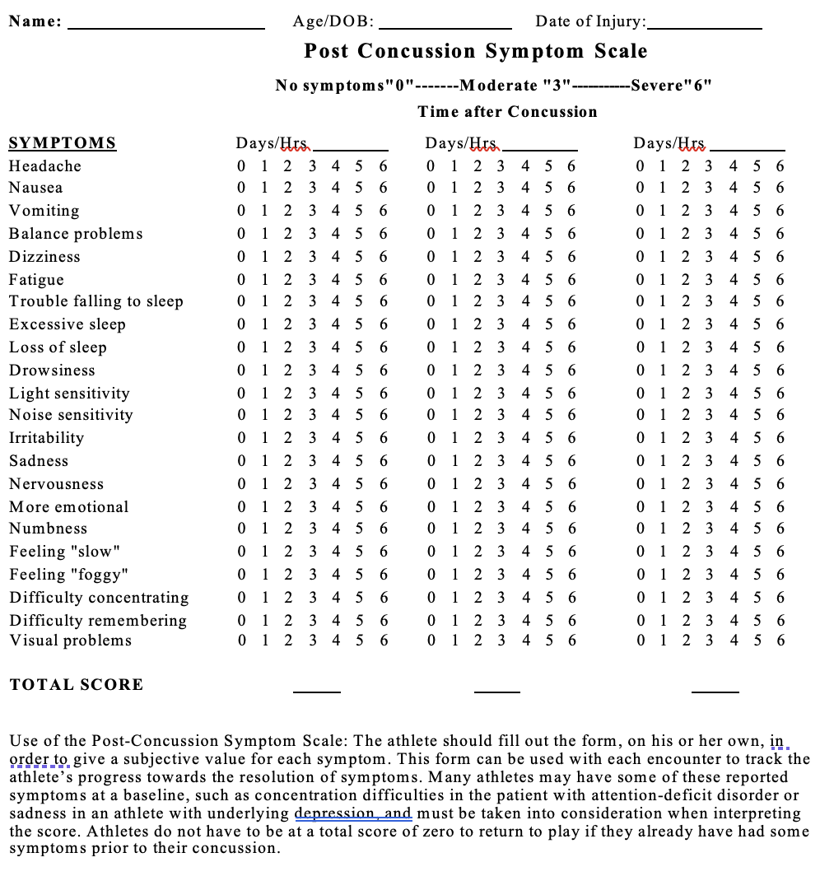

Pardini J, Stump J, Lovell MR, Collins MW, Moritz K, Fu F. The Post Concussion Symptom Scale (PCSS): a factor analysis [abstract]. Br J Sports Med. 2004;38:661-662.

